ANNEXURE - VI

Indian Institute of Technology, Kharagpur

Technology Profile of Invention for Commercialization

Title of the invention: A keystroke dynamics based system for synthesis of impostor data and normalization of energy level for user authentication and method thereof.

Innovator(s) who have contributed or conceived an essential element of the invention, either independently or jointly with others during evolution of the technology concept or reduction to practice:

Name: Dr. Sudipta Mukhopadhyay | Name: Rahul Arora
Position: Associate Professor | Position: M-Tech student (2012-2014)
Department: Electronics & EC Engg | Department: Electronics & EC Engg
Phone: 09434705935 | Phone: 08019809203, 09634361315
e-mail: smukho@ece.iitkgp.ernet.in | e-mail: rahulece.arora@gmail.com

Brief description of the invention:
(How does this invention relate to new processes, machines, compositions of matter, etc? Please cover the following points):

- Describe the invention so that the other faculty of the Institute who are knowledgeable in the field can evaluate the technical and commercial merits of the technology

Classifiers used for keystroke authentication are broadly classified under two categories, supervised and unsupervised learning. Supervised learning requires both legal as well as impostor data whereas unsupervised learning requires only legal user data for its implementation. For collecting the impostor data, login details of the legal user has to be disclosed to other users who are already registered and are requested to enter the login details on behalf of the legal user. This approach of generating impostor data has several drawbacks which are stated below.

- The login details of the user have to be disclosed to the other users already registered which compromises with the privacy of the user and makes the combination of username and password for protection altogether an illogical concept.

- This approach of generating impostor data becomes infeasible if the number of users increases. Each time a new user is registered, his or her login details have to be entered by the rest of the users which are already registered. This process takes a lot of time because each time all the rest of the users have to be called and are requested for entering the credentials on behalf of the legal user which can also be frustrating for them.

It is found through experiments that classifiers based on supervised learning gives better results as compared to that of classifiers based on unsupervised learning [Richard O.Duda, Peter E. Hart, David G.Stork, “Pattern Classification”, 2nd edition]. But use of supervised learning becomes impossible as collection of impostor data is an infeasible task for practical applications so a new technique is devised named as Impostor data synthesis for artificial collection of impostor data.

Also, the typing behavior of the user may vary from time to time because of his or her different energy level at different times, also known as intra class variation, and an improvement is done to make the data collected from the same user independent of the energy level.
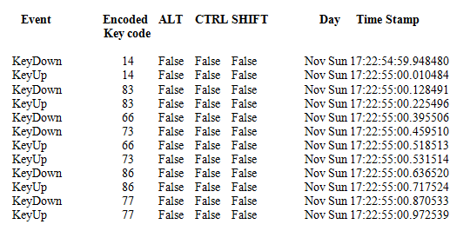
Fig 1: Format of data collected

Before implementing the technique of impostor data synthesis, free text data is collected from
various persons. For this a key logger executable program programmed in C sharp language is installed in the computers of various persons for some days. It runs in the background while the person can do his normal work without any interruption. It captures the events such as key pressed, key released and timings of the corresponding events and is written in a notepad file. For maintaining the security of the data the name of the keys are not written directly in the original form, it is first encoded and is then written in the encoded form as shown in Fig 1.

Proposed Method
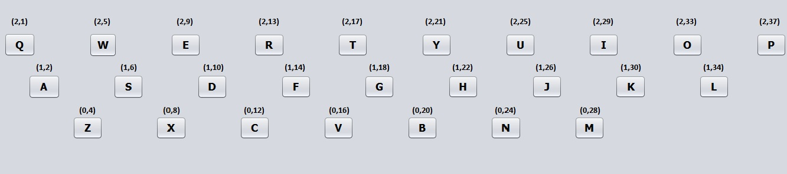
x and y coordinates are assigned to each of the alphabetic letter keys according to their position in the keyboard. For avoiding decimal coordinates the spacing between two consecutive keys in the same row is kept as same. As a demonstration, an expanded view of generic keyboard along with the coordinates assigned to it is shown in Fig 2.
Y
X
Fig 2: Arrangement of keys along with their coordinates

With the help of the assigned coordinates, radius and angle can be found out between any pair of keys using simple mathematical formulae.
A hypothesis is made which says that for a particular user, two different pairs of keys having same radius, angle and direction of movement of hands between the two key strokes will have same variation in timing of the keystrokes and both pair of key strokes can be considered as equivalent. For example, variation of the timings in transition from E to F can be considered equivalent to variation of the timings in transition from R to G, T to H and similarly with other pairs of keys. Also the transition from E to F (for e.g.) is considered different from transition from F to E as the direction of the movement of the hands changes in between the two keys. However this hypothesis is valid only if the user is made to type with a single hand and is known as Single Hand Approach.

For a normal typing process i.e. a person typing with both his hands, the variation of timings between different pairs of keys may come out to be different due to the change of the hands in between the two keys. It is assumed here that if two keys are pressed with different hands then the time between the two events is very small because as soon as the user presses one key the other key will be pressed within a small time gap as the other hand of the user will almost be near to the second key when he is typing the first key with a different hand. Whereas if a pair of keys are typed by the same hand then the time between the two events is more as compared to that of the previous case as the same hand takes more time to go from one key to the other. This time depends upon the separation between the two keys which is represented in the form of radius and angle between the two keys.

To make the stated hypothesis valid for a normal typing process, another dimension is added to each of the keys in addition to x and y coordinates. The keys of the entire keyboard are symmetrically divided into two parts. The keys on the left part are assigned a position as left hand which assumes that user types these keys using his or her left hand and similarly the right part of the keyboard is assigned a position of right hand. For finding an equivalent pair, apart from same radius, angle and direction of the movement of the hands, the sequence of hands typing the keys should also be same as that of the original pair. For example, if a person types a pair of keys which falls in the different parts of the keyboard then the equivalent pair of keys should also be in different parts of the keyboard. For example, variation of the timings in transition from E to F can be considered equivalent to variation of the timings in transition from R to G but cannot be considered equivalent to transition from T to H because typing TH involves a change of hand. This approach is known as Two hands Approach.

Procedure for Impostor data synthesis

In the present experiment ‘electronics’ is used as a password but the approach is valid for any typed string.

Step1. Free text or continuous keystroke data is collected from various persons for some days irrespective of the fact whether they are registered users or not. The procedure for this was already discussed earlier and the format of the data collected is shown in Fig 4.

Step2. New users are made to enroll and transition between each consecutive pair of key strokes in the typed password or string (electronics) is mapped to radius, angle and direction of the movement of the hands between the two key strokes.

Step3. An exhaustive search is made in each of the free text data file and equivalent transitions in terms of radius, angle and direction of the movement of the hands in between the two keystrokes are found for each consecutive pair of keys in the typed string using the Single hand approach or Two hands approach (discussed previously) as applicable. The timings of these equivalent pairs are written in a notepad file.

Step4: The entire file is searched so as to get as many equivalent transitions as possible for the considered pair of key strokes. If enough keystroke transitions are not available then the user model cannot be prepared.

Step5. Features like hold time and latency are calculated using the keystroke timings written in the notepad file. After calculation of features, feature vectors are formed and various classifiers based on supervised learning can be used for preparing the user model. The system is ready for verifying the identity of the user and can be tested by making the users to login into their account.

Collected continuous keystroke data from users (registered or not registered)
For new enrolled users map each consecutive keystroke transition in the string to its radius, angle and direction of the movement of the hands
Find equivalent transitions from the continuous data for each consecutive pair of keystrokes typed in the string
Check if there are enough transitions available for preparation of the user model.

Calculate Features and form feature vectors
Prepare User model using supervised learning approach

System is ready
for verifying the
identity of the user

Fig 3: Block diagram for impostor data synthesis

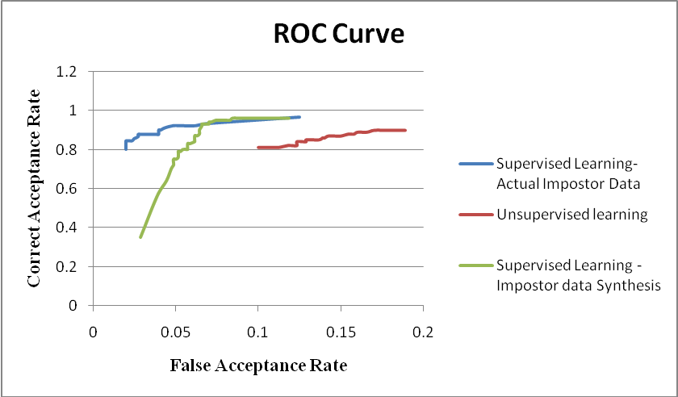
Fig 4: Comparison of results obtained for actual impostor data and impostor data synthesis

Some of the results captured are shown with the help of a graph in Fig 4. It can be observed that the supervised learning approach gives better results as compared to that of unsupervised learning approach. Supervised learning approach is tested with two techniques, with actual impostor data which is collected by disclosing the password of the legal user to the rest of the registered users in the system and with a new devised technique ‘Impostor Data Synthesis’. The graph shows that the former technique gives slightly better performance as compared to the latter, however as discussed previously it is completely an infeasible technique and can be only used for experimental purpose but the new technique gives approximately the same performance as compared to that of the actual impostor data using which supervised learning approach can be applied in practical applications.

- What are the advantages of the present invention over the comparable inventions?

- With the ease in the collection of impostor data, classifiers based on supervised learning can be easily used which gives a high accuracy as compared to classifiers based on unsupervised learning.
- Also features are made independent of the energy level of the user. With these two new techniques implemented, the overall accuracy of the system gets improved which makes the system more robust for practical applications.

- Has the invention been tested experimentally? Are experimental data available?

The invention has been successfully tested and some of the results obtained have been shown in Fig 4. All the experimental data required has been successfully collected as was shown in Fig 1.

- Has the invention been patented or protected under confidentiality agreement?

No, the invention has not been patented or presented in any journal or research paper.

ANNEXURE – VI (contd)
Commercial Potential:

What are the:
- Possible uses/application areas and/or products you feel may embody aspects of your technology
The present invention can result in a system capable of one time and continuous time keystroke authentication and can be used in any organization where computers are used and its security is the topmost concern.

- Possible end-users
Any user using a computer system, a smart phone or any electronic gadget which allows user access after taking the login information like username and password.

- Potential marketability including commercial suggestions viz.
  - input required
  - production capacity where applicable
  - raw material requirement
  - transfer form
  - target companies and countries,
  - economic data
  - potential long-term commercial interest.

(please provide as much information as possible; attach extra sheets of required)

Prior disclosure and possible intent:

- Has the invention been disclosed to industry representatives or third parties?
There has not been any kind of disclosure to industry representatives or third parties.

- Has any commercial interest been shown in it and of what nature? Name companies and specific individuals and their titles.
Till now there has not been contact to any of the companies related to the invention.

Development stage:

Give your opinion on the current stage of development of the invention as it relates to its
marketability (indicate appropriate response):

_________ Embryonic (needs substantial work to bring to market)

_________ Partially developed (could be brought to market with significant investment)

_________ Off-the-shelf (could be brought to market with nominal investment)

Do you know of any other inventions that are congruent with this invention?

As discussed earlier the impostor data can be collected by disclosing the login details of the legal user to other users who are already registered and are requested to enter the login details on behalf of the legal user but this technique is only limited for experimental purpose and no such invention has been found which solves the problem effectively for practical applications.

Signature of inventor with date Signature of inventor with date

__________________________ __________________________

Signature of inventor with date Signature of inventor with date

__________________________ __________________________

